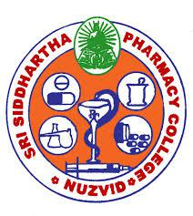
SRI SIDDHARTHA PHARMACY COLLEGE
(Approved by AICTE, New Delhi; PCI, New Delhi and Government of Andhra Pradesh)
Affiliated to Krishna University
Ammavarithota, NUZVID-521201, Eluru District, Andhra Pradesh, India
Dr. P. G SUBBA RAO
Professor and Principal

ANTI- DISCRIMNATION CELL

The following members are selected for anti- discrimination cell. The members are aimed to identify any discriminations happened in the campus and to take corresponding prohibitory action to stop such events in further future.

NAME OF THE CHAIRPERSON OF CELL: Mrs. M.PRAVEENA KUMARI
NAME OF THE CO- CHAIRPERSON OF CELL: Dr. G SUBBA RAO
COMMITTEE MEMBERS

- Ms. LAVANYA LATHA MATHANGI: ASSISTANT PROFESSOR
- Mrs. S.K.SHARMILA : LAB ATTENDER
- T.GOPI CHAND: II YEAR
- R NAGA LAKSHMI: II YEAR
- V NAVEEN KUMAR: III YEAR
- P DEEPA : III YEAR
- P DURGA RAO: IV YEAR
- N GOPAL REDDY: IV YEAR

Ammavari thota, NUZVID-521201, Eluru District, Andhra Pradesh, India
Ph: 08656- 233969, 9292252981 e-mail id: principalspcn99@gmail.com,www.spcn.in

